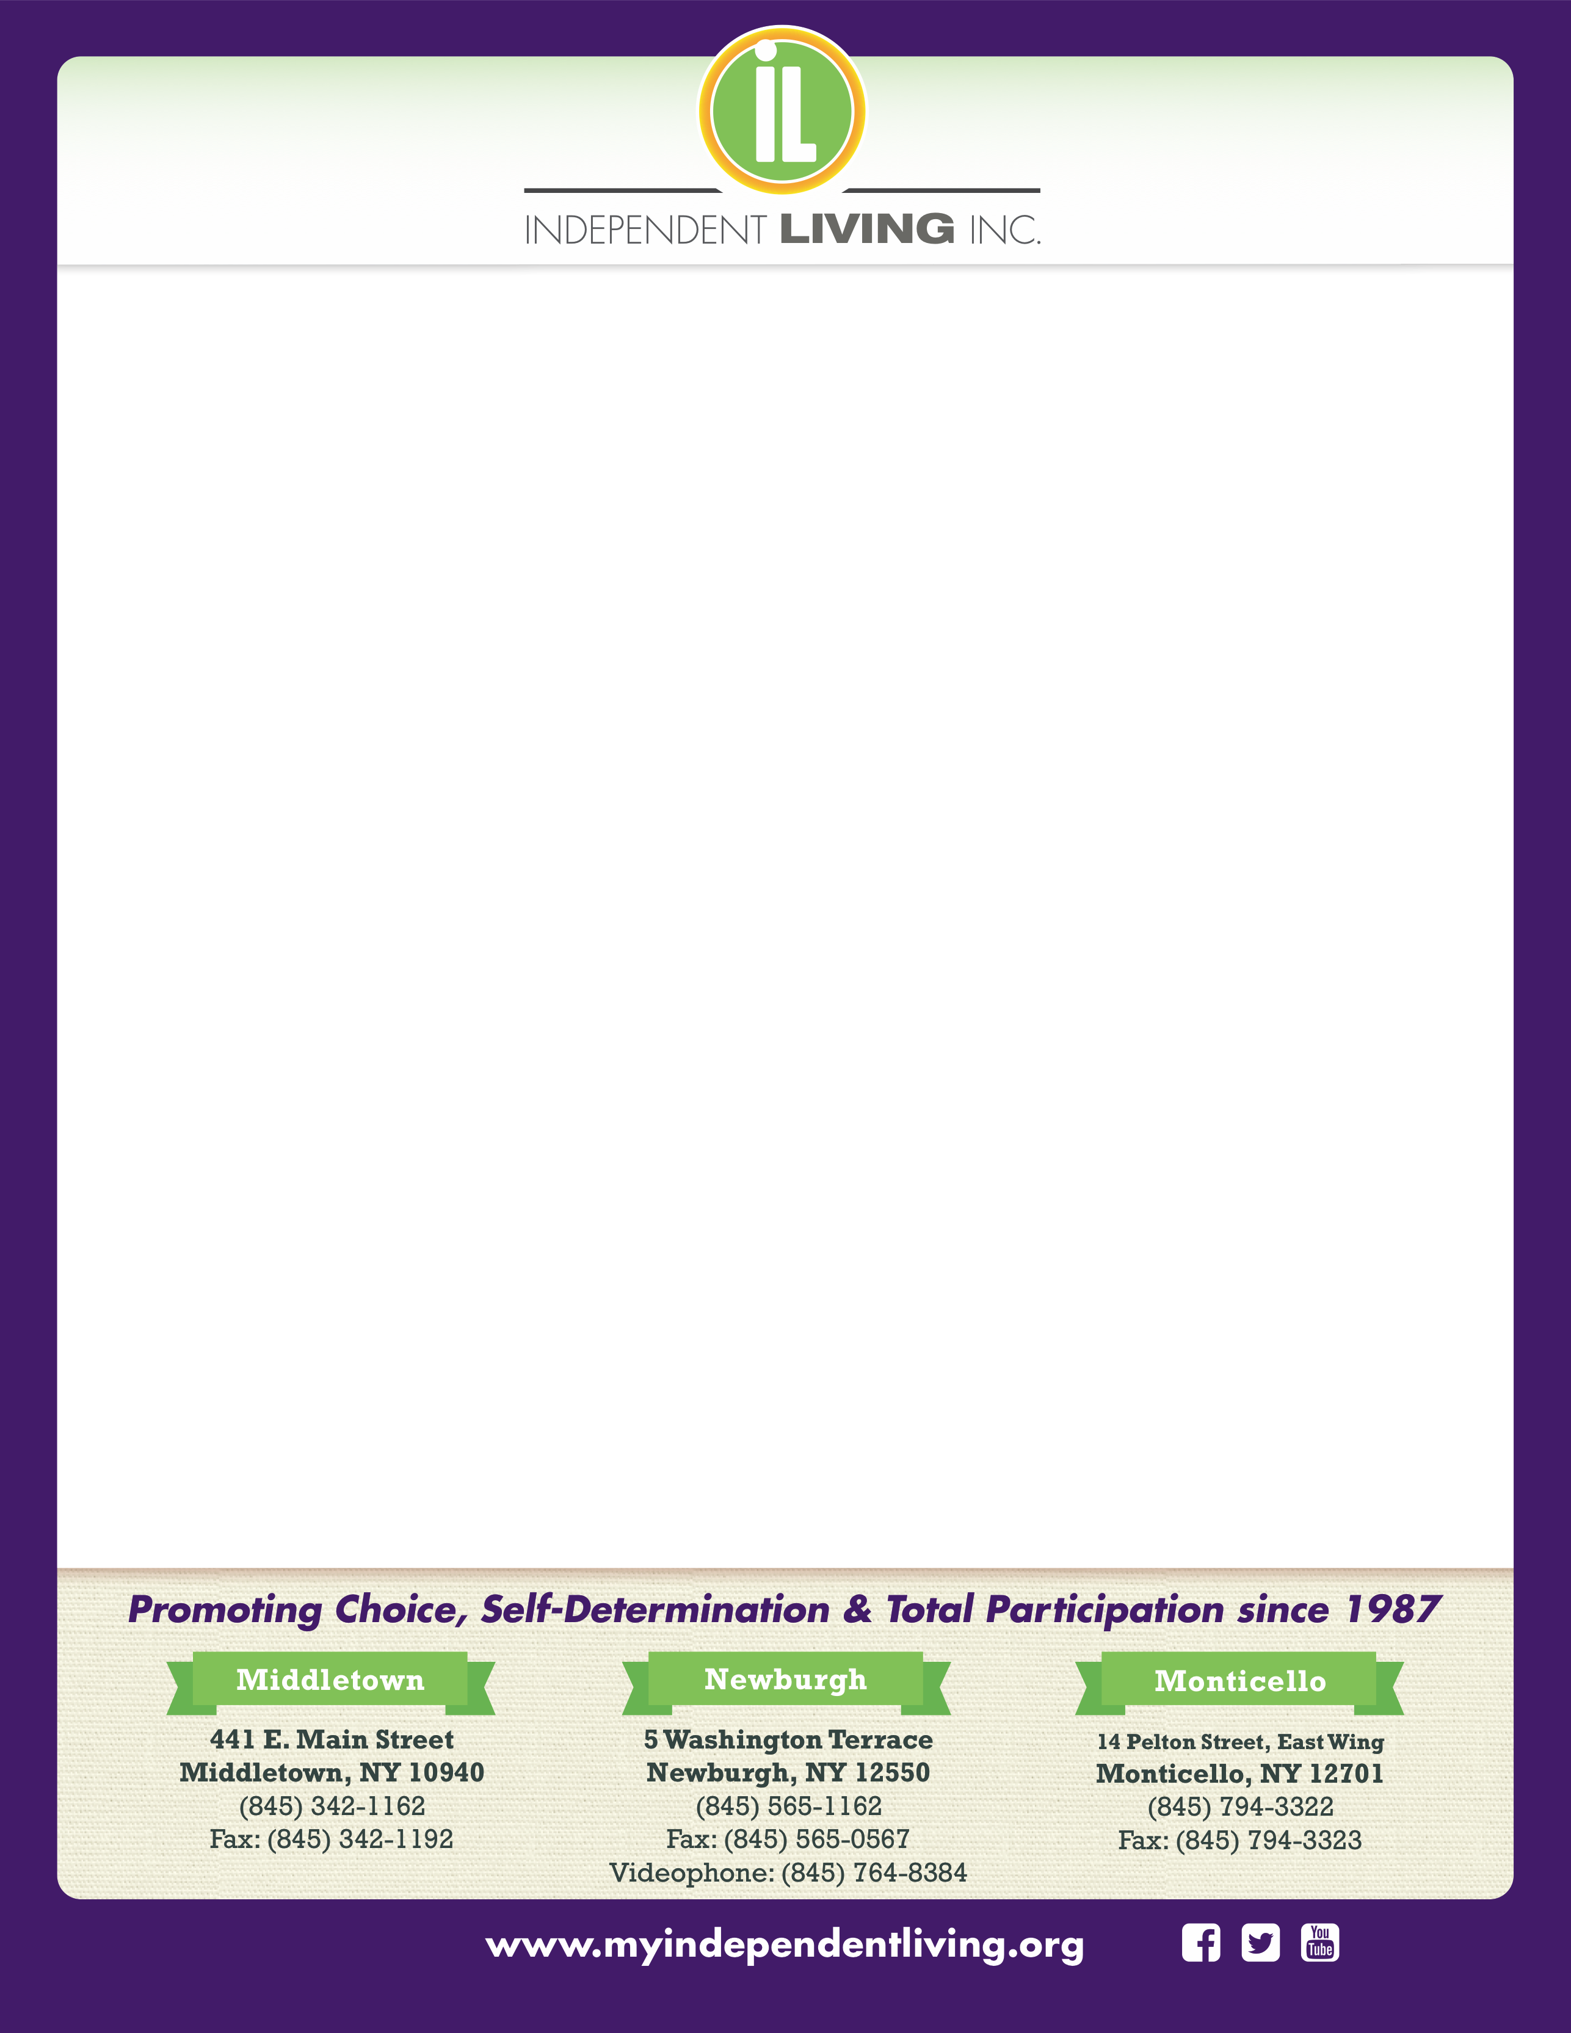

xxxxxxxxxxxxxxxxxx

**FREE Virtual webinar offered by Goshen Central School District!**

**Preparing for your child’s Annual Review Meeting**

**Presented by:**

**Diane Troeller – Education Advocate**

**Lisa Cohen- Education Advocate**

Independent Living and Goshen Central School District are offering this FREE training as part of our Education Advocacy workshops for students with disabilities of all ages and their parents/guardians.

***January 21, 2025 at 6:00pm***

**Virtual session via ZOOM-Link will be emailed up receipt of RSVP**

**RSVP to** [**lcohen@myindependentliving.org**](mailto:lcohen@myindependentliving.org)

**Our training series is designed to help parents and students develop as self-advocates by learning the necessary skills and knowledge to navigate special education and transition to adult services.**

**This training will cover the following:**

* **Understanding the purpose of the meeting**
* **Understanding the components of the annual review meeting**
* **Strategies/tips to prepare for meeting**
* **Q & A**

***Training Funded by: New York State Office for People with Developmental Disabilities Family Support Services***

**\*RSVP BY EMAILING LISA COHEN AT LCOHEN@MYINDEPENDENTLIVING.ORG**